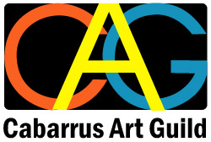
CABARRUS ART GUILD
c/o ClearWater Arts Center & Studio
223 Crowell Dr. NW
Concord, NC 28025

Membership Enrollment

NAME: __________________________________________________

ADDRESS: __________________________________________________
__________________________________________________
__________________________________________________

EMAIL: __________________________________________________

PHONE: (______)___________________________________________

Membership Fee

$40.00 if paid before January 1st.
Membership fee
(Included with this form)
$20.00 if paid after December 31st.

Method of Payment:

CHECK (Please make checks payable to: Cabarrus Art Guild)

Mail to:
Cabarrus Art Guild
c/o ClearWater Arts Center & Studio
223 Crowell Dr. NW
Concord, NC 28025

Date Paid : ________ Amount: __________ Rec'd by ________

